# [https://avatars2.githubusercontent.com/u/4156894?v=3&s=100](http://www.calstatela.edu/centers/hipic) CIS52000 Term Project Tutorial

#### Authors: Aakriti Rupal; Phue Thant; Anish Pandey; Vatsal Pancholi

#### Instructor: [Jongwook Woo](https://www.linkedin.com/in/jongwook-woo-7081a85)

#### Date: 05/22/2022

**Lab Tutorial**

Aakriti Rupal (arupal[@calstatela.edu](mailto:@calstatela.edu)), Phue Thant ([pthant@calstatela.edu](mailto:pthant@calstatela.edu)),

Anish Pandey ([apandey9@calstatela.edu](mailto:apandey9@calstatela.edu)), Vatsal Pancholi (vpancho@calstatela.edu)

5/22/2022

**US Used Cars Data Analysis​ using Hive**

## Objectives

US is one of the largest markets for used cars sales. Public data repositories like Kaggle offer such large datasets that are available to everyone.

In this hands-on lab, you will learn how to:

* Source data from Kaggle and upload it to HDFS
* Data cleanup and validation
* Utilize HIVEQL commands to perform analysis
* Utilize power BI and excel for visualization

## Introduction

In this tutorial you will use HIVEQL to analyze a large dataset for used cars sales to get insights into the different car attributes that affect the used cars sales price. The analysis will also cover visualizations to get useful insights. In this tutorial you will learn the following:

1. Download and clean large dataset
2. Upload the dataset to HDFS
3. Create HIVE table to validate uploaded data
4. Create HIVE queries to perform descriptive analysis
5. Create HIVE queries to perform statistical analysis to determine the factors that affect used car prices
6. Utilize Power BI and Excel 3D maps for visualization

## Platform Specifications

* Cluster version: Hive 3.1.2-amzn-4
* CPU Speed: 8 Core CPU (Intel(R) Xeon(R) Platinum 8167M CPU @ 2.00GHz)
* # Of CPU cores: 8
* # Of nodes: 3 node cluster​
* Total Memory Size: 58.58 GB

## Dataset Details

* Dataset Name: US Used cars dataset
* Dataset URL:​ <https://www.kaggle.com/datasets/ananaymital/us-used-cars-dataset>
* Total Size:​​ 9.98 GB
* Number of Files: 30
* File Format:​ CSV

## Pre-requisites

For the purpose of this lab, following requirements must be met:

1. You must have an account Power BI website
2. You must have Microsoft excel 2010, 2013 or 2016 installed which has excel 3D map enabled (Does not work on excel for mac)
3. You should have a GitHub account and access to the following repository ([https://github.com/arupal23/CIS-5200-Project Files/settings/access?query=filter%3Acollaborators](https://github.com/arupal23/CIS-5200-Project%20Files/settings/access?query=filter%3Acollaborators))

## Lab Steps

Follow the following steps to complete the lab:

### Step 1: Download and clean the dataset

Use the below steps to download and clean the data

1. Download the Dataset for US Used cars dataset from Kaggle <https://www.kaggle.com/datasets/ananaymital/us-used-cars-dataset>

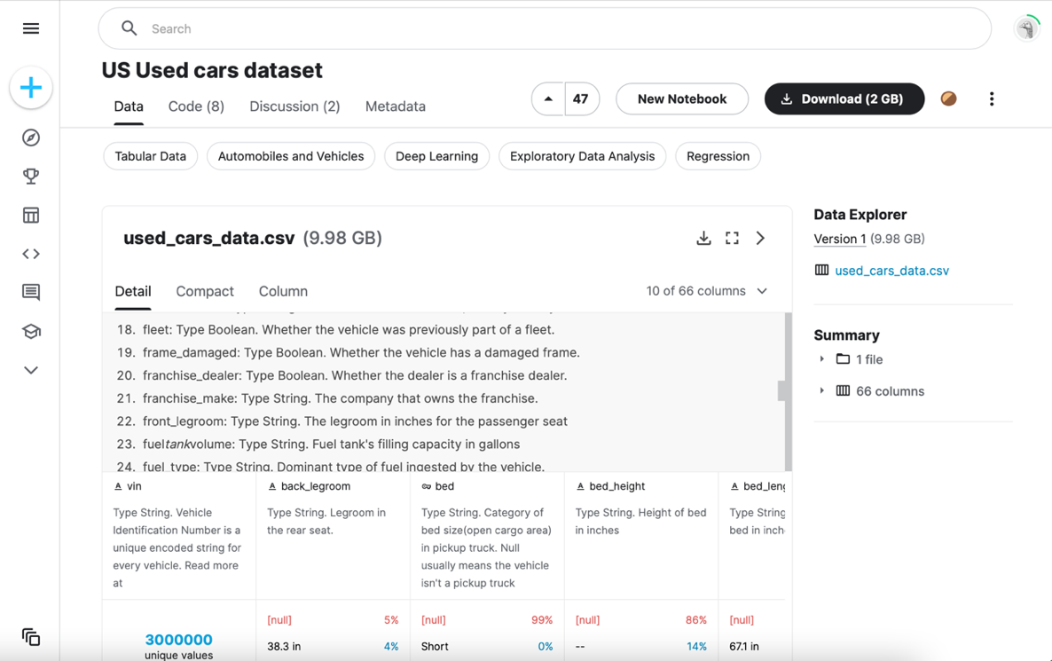

1. Since the file size is large, you cannot use excel to clean the dataset. Use the following command to split the used_car_data.csv into smaller files. (-l argument is used to specify the number of lines that’s present in each split. Last argument (usedcarsdata_split) is to specify the prefix for the split files

$ split -l 100000 usedcarsdata.csv usedcarsdata_split

1. The above command will generate 30 files with names usedcarsdata_splitaa, usedcarsdata_splitab usedcarsdata_splitac and so on
2. Rename each of the files and add a .csv extension
3. Clean the data by standardizing the datatypes consistently across all columns.
4. Replace all blanks in numerical columns (fuel_economy, mileage, etc.) to 0.
5. Remove units from numerical columns (e.g. for bed_length, remove “in” from all bed length measurements).
6. Replace all “,” in description and other fields with “;” as it will cause issues when loading a .csv file.

### Step 2: Download code base from GitHub

1. You need to download code from Git Hub (<https://github.com/arupal23/CIS-5200-Project-Files>)
2. You need to download the .txt files present in the following folders
   * Data Download and Cleanup
   * Data Validation
   * Exploratory Analysis
   * Analysis of factors affecting price
3. You can also use the link to clone GitHub repository if you have GitHub client installed (gh repo clone arupal23/CIS-5200-Project-Files)
4. The code included in the files are also detailed in the steps below

### Step 3: Upload the file to Hadoop File System (HDFS)

To manually upload the data to HDFS, you must transfer it to Linux directory first using scp command.

1. You may open Git Bash, putty (windows) or “terminal” (Mac) to connect to Hadoop Server. You can also use any other ssh/scp/sftp client to connect to the server
2. You need to run the below scp command to copy the cleaned csv files to Linux directory of Hadoop server

$ scp your-file-path/usedcarsdata*.csv [yourusername@ipaddress:/home/yourusername/](mailto:yourusername@35.87.184.21:/home/%20yourusername/)

1. Replace the file path (Downloads/UsedCarsDataFile) with the file path at your computer
2. You need to replace arupal with [your username]

### Step 4: Remotely connect to Hadoop cluster using ssh

1. You need to remotely access your Hadoop Cluster (IP provided by your instructor) using your Hadoop Cluster account using ssh (Git Bash, putty (windows) or “terminal” (Mac))

-bash-4.2$ ssh arupal@129.146.154.176

1. Input password and press enter.
2. Replace arupal with [your username]
3. Run ls command on Linux to see the used cars data uploaded to Linux from your PC

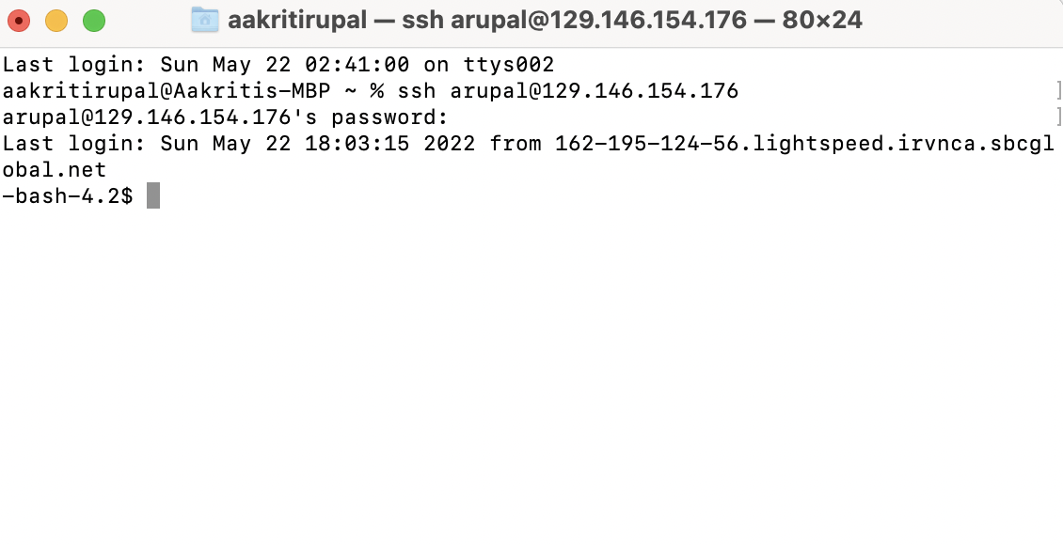

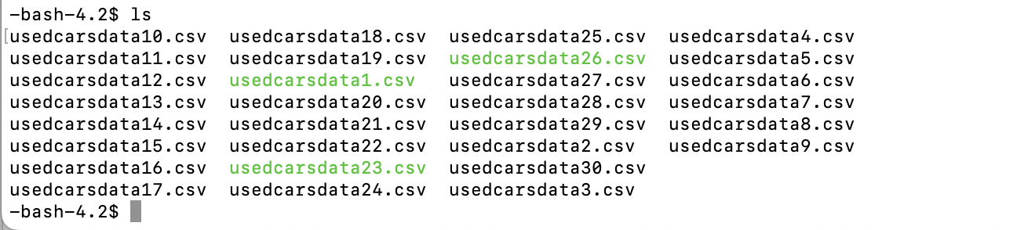

### Step 5: Create a directory to put upload the dataset to HDFS

1. Run the following command to create a directory “used_cars” on HDFS

-bash-4.2$ hdfs dfs -mkdir used_cars

1. Next, run the following command to see if the directory is created

-bash-4.2$ hdfs dfs -ls

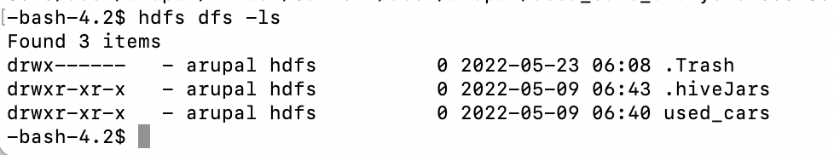

1. Use the following shell command to put file in the used_cars directory created in step (4-a)

-bash-4.2$ hdfs dfs -put usedcarsdata*.csv used_cars

1. Run the following command to make sure that the files have been uploaded to the used_cars directory on HDFS

-bash-4.2$ hdfs dfs -ls used_cars

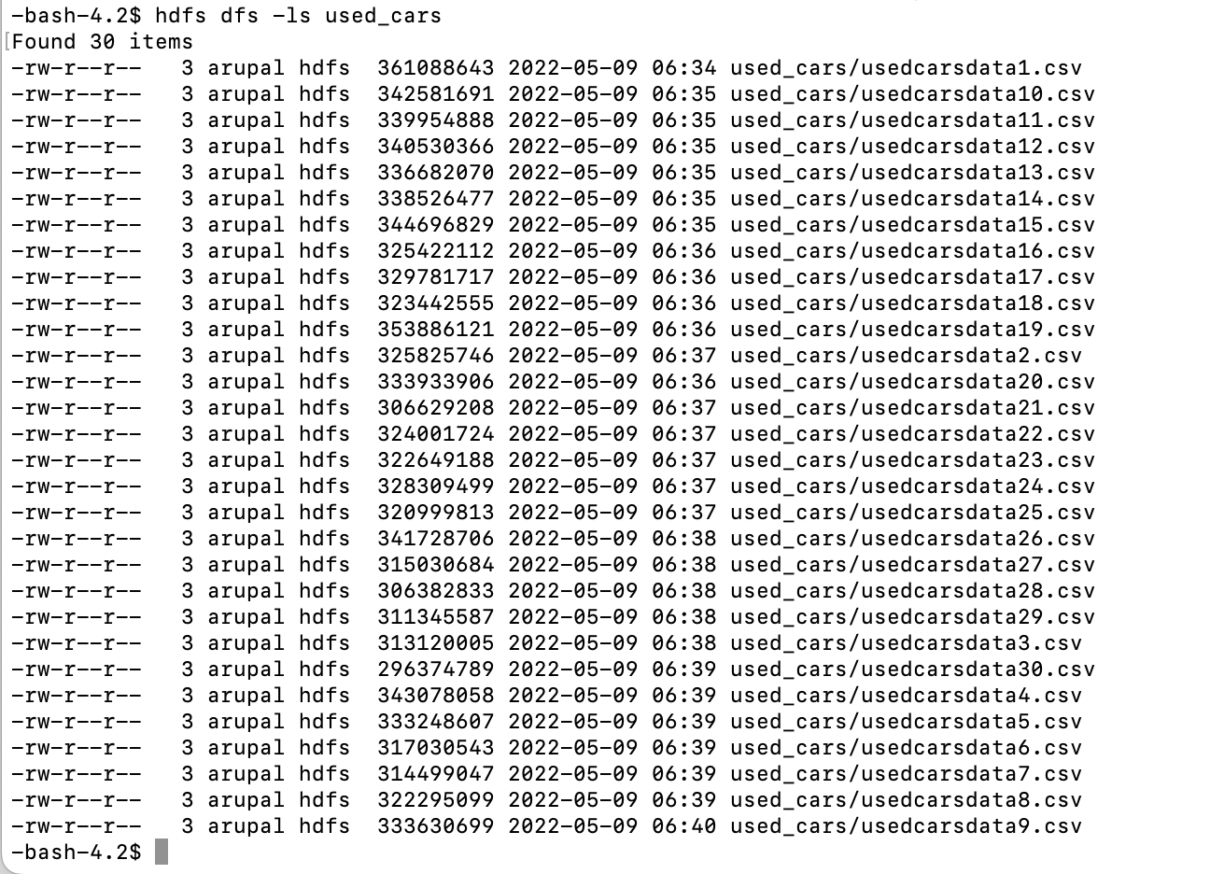

1. Now remove the files from Linux after uploading them to HDFS

-bash-4.2$ rm usedcarsdata*.csv

1. Next you need to create “data” directory which will be used to export all analysis results.

-bash-4.2$ hdfs dfs -mkdir data

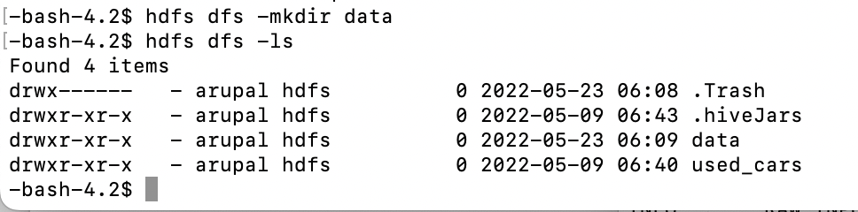

### Step 6: Connecting to HIVE using Beeline CLI

1. Open beeline CLI (Command Line Shell Interface) that is equivalent to hive CLI

-bash-4.2$ beeline

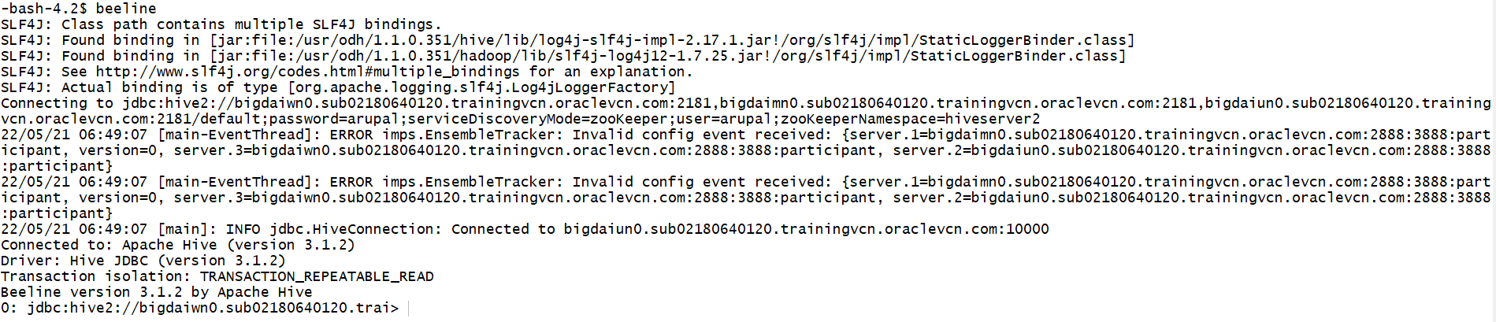

1. In the beeline shell, run “use your_database_name;”. Replace your_database_name with the name of your database

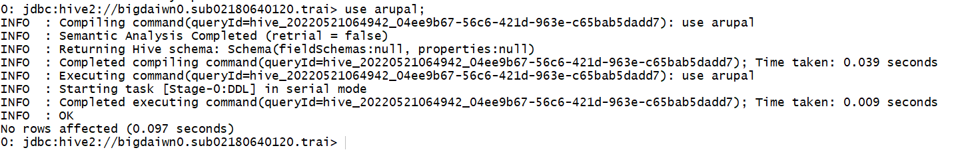

1. Create Hive Table - The following HIVE statement creates an external table for used_cars. External tables are created as they store the data in the original file format and at the same time allow HIVE to perform queries on the data within the file
2. You need to copy and paste the following HiveQL code to create an external table used_cars for analysis

CREATE EXTERNAL TABLE IF NOT EXISTS used_cars (vin VARCHAR(128), back_legroom DECIMAL(6,1), bed VARCHAR(32), bed_height STRING, bed_length DECIMAL(6,1), body_type VARCHAR(64), cabin STRING, city VARCHAR(64), city_fuel_economy INTEGER, combine_fuel_economy STRING, daysonmarket INTEGER, dealer_zip INTEGER, description String, engine_cylinders VARCHAR(8), engine_displacement INTEGER, engine_type VARCHAR(8), exterior_color VARCHAR(16), fleet VARCHAR(16), frame_damaged VARCHAR(16), franchise_dealer BOOLEAN, franchise_make VARCHAR(16), front_legroom DECIMAL(5,2), fuel_tank_volume DECIMAL(5,3), fuel_type VARCHAR(16), has_accidents BOOLEAN, height DECIMAL(7,2), highway_fuel_economy INTEGER, horsepower INTEGER, interior_color VARCHAR(16), isCAB BOOLEAN, is_certified BOOLEAN, is_cpo BOOLEAN, is_new BOOLEAN, is_oemcpo BOOLEAN, latitude DECIMAL(8,5), body_length DECIMAL(3,2), listed_date DATE, listing_color VARCHAR(16), listing_id DECIMAL, longitude DECIMAL(9,5), main_picture_url STRING, major_options STRING, make_name VARCHAR(16), maximum_seating INTEGER, mileage INTEGER, model_name STRING, owner_count INTEGER, power STRING, price INTEGER, salvage BOOLEAN, savings_amount INTEGER, seller_rating DECIMAL(11,9), sp_id INTEGER, sp_name VARCHAR(16), theft_title BOOLEAN, torque STRING, transmission VARCHAR(2), transmission_display STRING, trimId STRING, trim_name VARCHAR(16), vehicle_damage_category STRING, wheel_system VARCHAR(16), wheel_system_display VARCHAR(16), wheelbase DECIMAL(6,3), width DECIMAL(3,1), vehicle_year STRING) ROW FORMAT DELIMITED FIELDS TERMINATED BY ',' STORED AS TEXTFILE LOCATION '/user/arupal/used_cars' TBLPROPERTIES ('skip.header.line.count'='3');

1. You need to make sure that the table used_cars was created in your database. Use the following command to check the table created.

show tables;

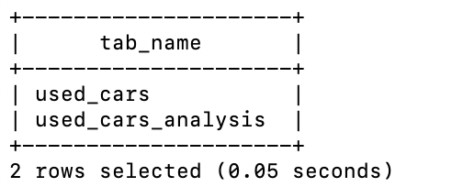

1. Now to verify if the count of data is correct, run the following command.

SELECT COUNT(*) from used_cars;

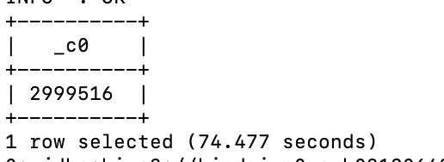

1. Then, you need to check if the table “used_cars” can be used to query the HDFS files that was uploaded (Verify table has data)

select * from used_cars Limit 10;

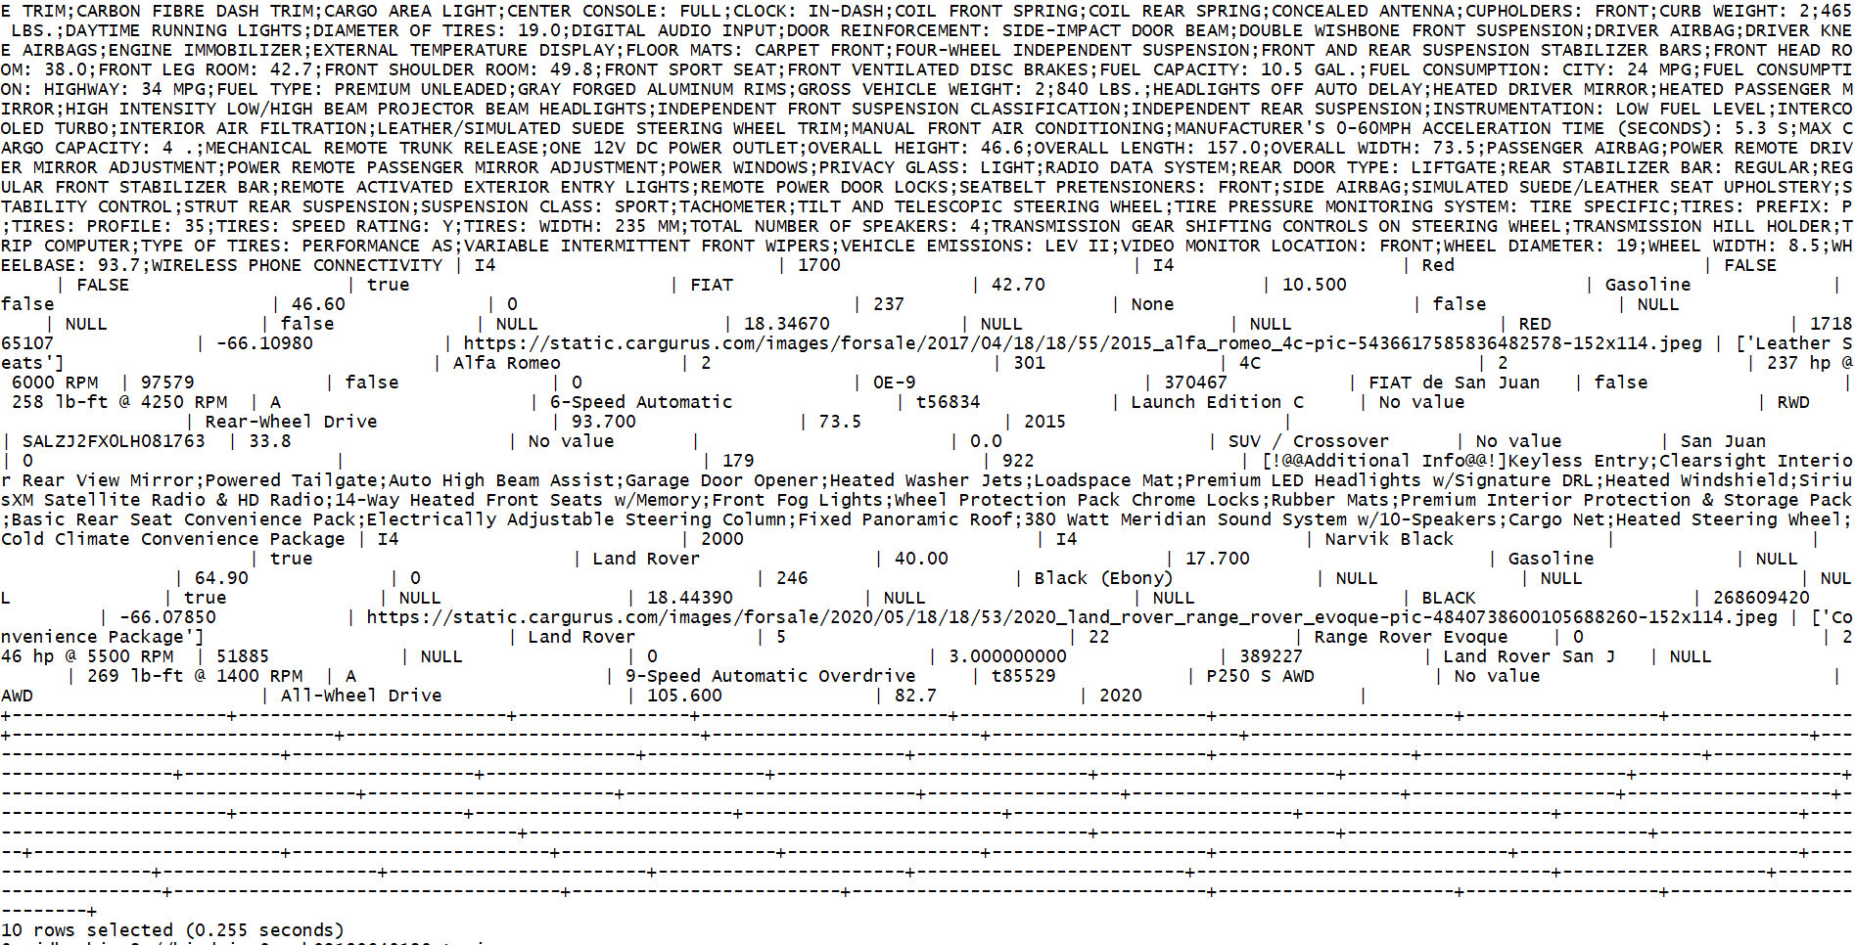

### Step 7: Commands for data validation

1. Next, you need to run a SELECT command to validate the data that would show the vin, body type, make name, maximum seating, wheel system and price from the dataset. Run the following Hive code in the Beeline shell:

select vin, body_type, make_name, maximum_seating, wheel_system, price from used_cars LIMIT 10;

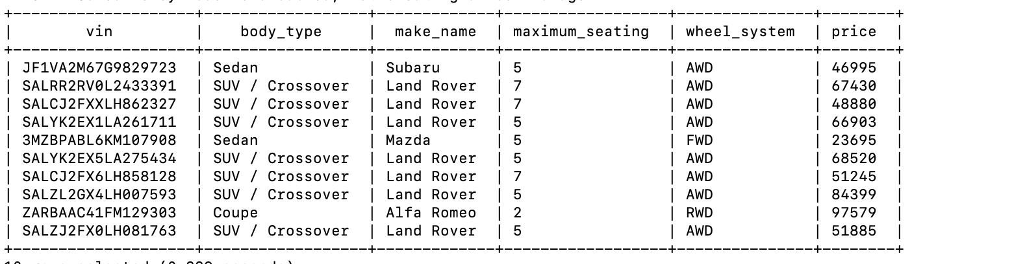

1. You may get output that looks slightly different from the above screenshot. Hive uses map reduce to query the data and depending on the sequence of execution, different rows may be selected when running with limit command

### Step 8: Descriptive analysis - Descriptive analysis will illustrate the characteristics and relationships of the different factors that affect the price of the used cars. You will execute a series of queries that will highlight the relationships of two factors (per query) that affect the price of used cars. You will also develop visualizations that will provide insights into patterns and relationships of these factors. The different analytics and visualizations for descriptive analysis is as below:

1. Effect of car engine size on fuel economy:
2. You need to run the below select command to determine the average fuel economy for each engine type. This will give you engine type ordered by highest fuel economy.

SELECT engine_type AS car_engine_type, ceil(AVG(city_fuel_economy)) AS avg_fuel_economy FROM used_cars GROUP BY engine_type ORDER BY avg(city_fuel_economy) DESC LIMIT 10;

1. Output of the query is as below:

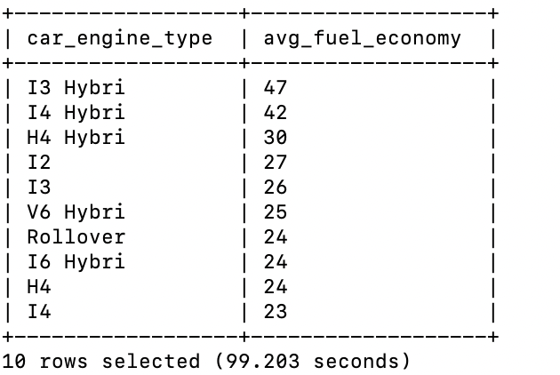

1. Next, you need to extract the query results and download it to your laptop to create a visualization. First step is to run the below command to dump the query result into HDFS file.

INSERT OVERWRITE DIRECTORY '/user/arupal/data/' ROW FORMAT DELIMITED FIELDS TERMINATED BY ',' SELECT engine_type AS car_engine_type, ceil(AVG(city_fuel_economy)) AS avg_fuel_economy FROM used_cars GROUP BY engine_type ORDER BY avg(city_fuel_economy) DESC LIMIT 10;

1. Downloading data to your PC - Open a new terminal and connect to Linux server.

ssh arupal@129.146.154.176

1. Replace arupal with your usename. Enter your password to login

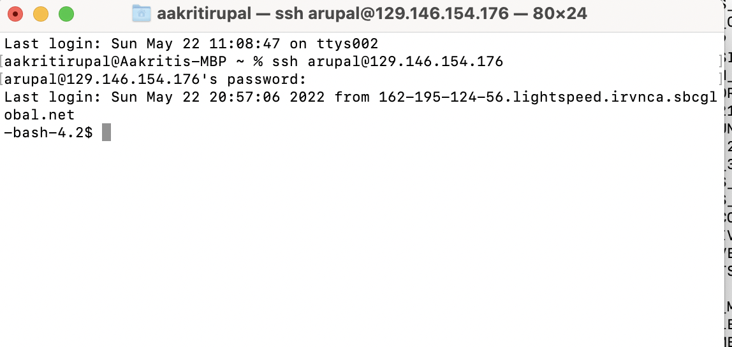

1. On Linux, run ls command on Hadoop file system to verify that the file with query results was created

$ hdfs dfs -ls data/

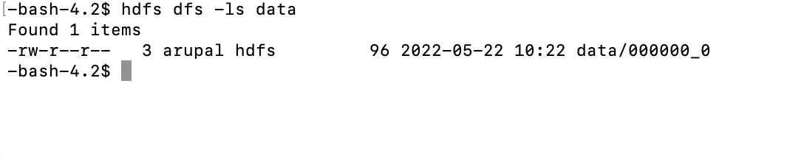

1. Next, copy the file from HDFS to Linux using the -get command. Last argument in the command will rename the file on the Linux side to enginefueleconomy.csv

$ hdfs dfs -get data/000000_0 enginefueleconomy.csv

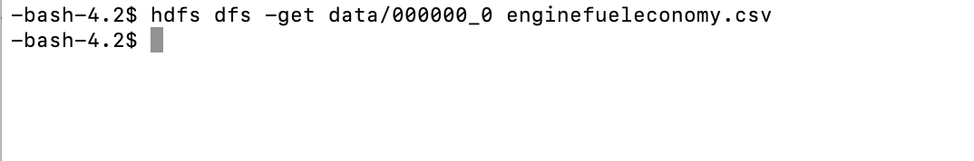

1. Since the data has been copied to Linux file system, remove the file from HDFS using the following command

$ hdfs dfs -rm data/000000_0

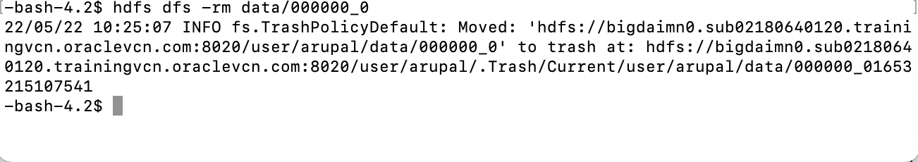

1. Run a -ls to verify that the file has been deleted from HDFS.

-bash-4.2$ hdfs dfs -ls data

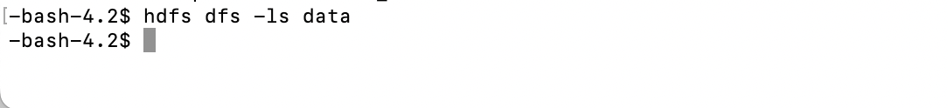

1. Next, remotely download the output “enginefueleconomy.csv” to your PC using the below scp command.

$ scp [arupal@129.146.154.176:/home/arupal/enginefueleconomy.csv](mailto:arupal@129.146.154.176:/home/arupal/enginefueleconomy.csv) .

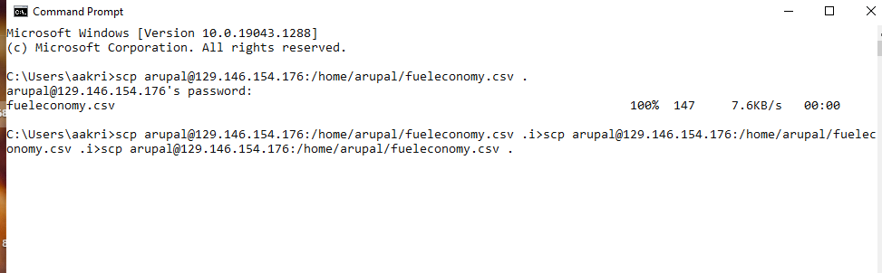

1. Visualization using Excel - You need to create a 3-D bar graph for visual representation of the output in excel. Open the .csv file in an excel and add headers after inserting the first row in the excel. Add headers as “car_engine_type” and “avg_fuel_economy”.
2. Now, to create the bar graph, select the data and go to Insert > then 3D clustered column chart. Click on the 3D clustered chart and select from different chart designs.

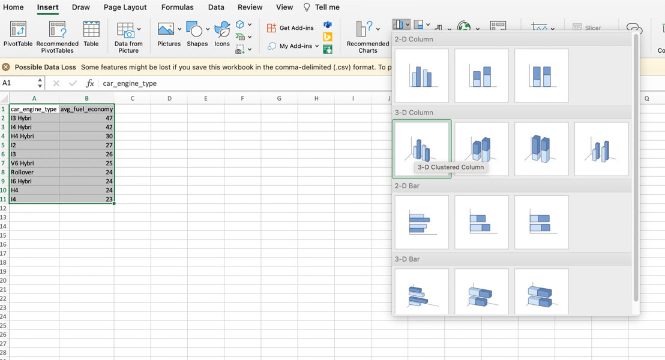

1. Generate 3-D bar graph by clicking on the 3-D Clustered Column chart 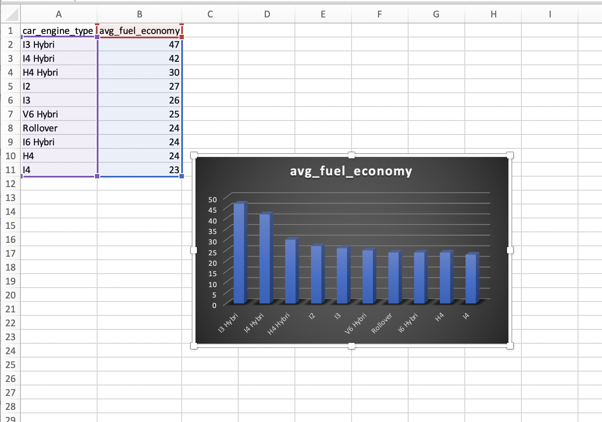
2. Verify that the generated bar graph is as below
3. Number of cars sold based on the car type
4. For the next analysis, you need to run the below command to see the number of cars that were sold based on the car type.

select body_type AS car_type, count(vin) AS number_of_cars_sold from used_cars group by body_type order by count(vin) desc limit 5;

1. On running the above command, verify that the output is as below

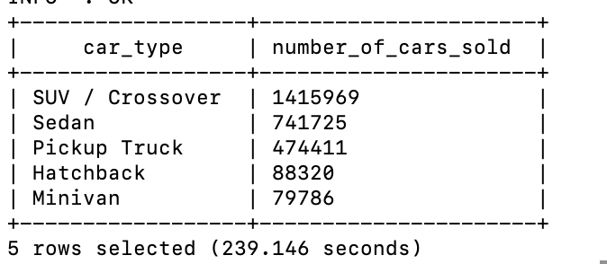

1. Now, you need to move the query result to HDFS using the following command. Use the reference of sections iii through xiv for screenshots. The filenames, directory names and visualizations will change based on the below commands

INSERT OVERWRITE DIRECTORY '/user/arupal/data/' ROW FORMAT DELIMITED FIELDS TERMINATED BY ',' select body_type AS car_type, count(vin) AS number_of_cars_sold from used_cars group by body_type order by count(vin) desc limit 5;

1. Downloading data into your PC - Open the Linux terminal and run the below command to see if the file has been moved to Linux

$ hdfs dfs -ls data/

1. Next, copy the file from HDFS to Linux using the -get command

$ hdfs dfs -get data/000000_0 cartype.csv

1. Now, you can remove the file from HDFS using the following command

$ hdfs dfs -rm data/000000_0

1. Next, to remotely download the output “cartype.csv” to your PC using the below scp command.

$ scp [arupal@129.146.154.176:/home/arupal/cartype.csv](mailto:arupal@129.146.154.176:/home/arupal/cartype.csv) .

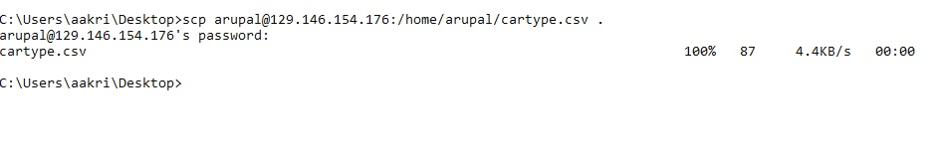

1. Visualization for Excel - Open the file and add column headers “car_type” and “No_of_cars_sold”. For visualization, open the .csv file in an excel and create the bar graph using Insert > 3D clustered column chart. You can refer to the details (ix to xiv) of the previous descriptive analysis section. Verify that the visualization is as per the below screenshot:
2. Number of cars sold based on the car model
3. For this analysis, you need to run the following code to get the numbers of cars sold based on the car model

select CONCAT(make_name, " ", model_name) cars_model, COUNT(vin) AS number_of_cars_sold from used_cars group by CONCAT(make_name, " ", model_name) order by COUNT(vin) desc limit 20;

1. Verify that the output is as below:

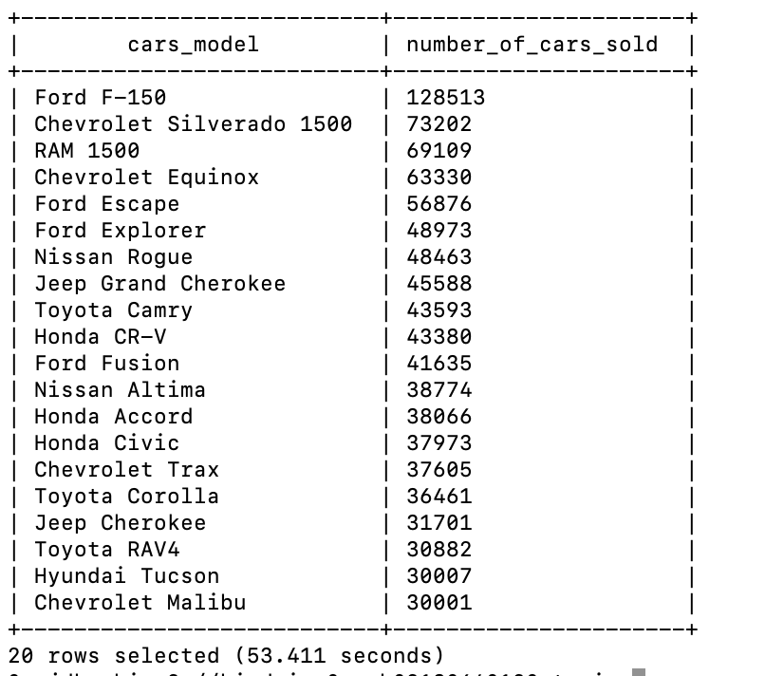

1. You need to run the below command to dump the query result into HDFS file.

INSERT OVERWRITE DIRECTORY '/user/arupal/data/' ROW FORMAT DELIMITED FIELDS TERMINATED BY ',' select CONCAT(make_name, " ", model_name) cars_model, COUNT(vin) AS number_of_cars_sold from used_cars group by CONCAT(make_name, " ", model_name) order by COUNT(vin) desc limit 20;

1. Downloading data into your PC - Switch to the Linux server to copy the data from HDFS to Linux directory. On the Linux terminal, run an -ls command to verify that the file with query results was created

$ hdfs dfs -ls data/

1. Move the file from HDFS to Linux using the -get command

$ hdfs dfs -get data/000000_0 carmodel.csv

1. Now, you can remove the file from HDFS using the following command

$ hdfs dfs -rm data/000000_0

1. You can remotely download the output file “carmodel.csv” to your PC to visualize it using Excel

$ scp [arupal@129.146.154.176:/home/arupal/carmodel.csv](mailto:arupal@129.146.154.176:/home/arupal/carmodel.csv) .

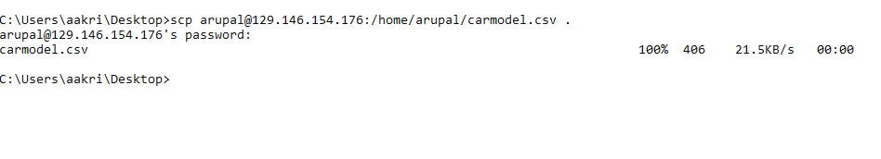

1. Visualization in Excel - You need to create a bar graph in excel for a graphical representation of the output. Now, open the excel and add headers to the file; “cars_model”, “number_of_cars_sold”. Select the data for the graph, and go to INSERT > 2D column chart, to insert a bar graph as below.
2. Number of cars sold and the average price of the car for different vehicle years for Ford F – 150
3. In the last step, you saw that Ford F-150 is the highest selling cost model. In this step, you need to analyze the number of cars sold and the average price of Ford F-150 for different vehicle years.

select vehicle_year, count(vin) AS number_of_cars_sold, ceil(avg(price)) AS average_price from used_cars where CONCAT(make_name, " ", model_name) = 'Ford F-150' group by vehicle_year order by vehicle_year desc limit 20;

1. Verify that the query result is as below

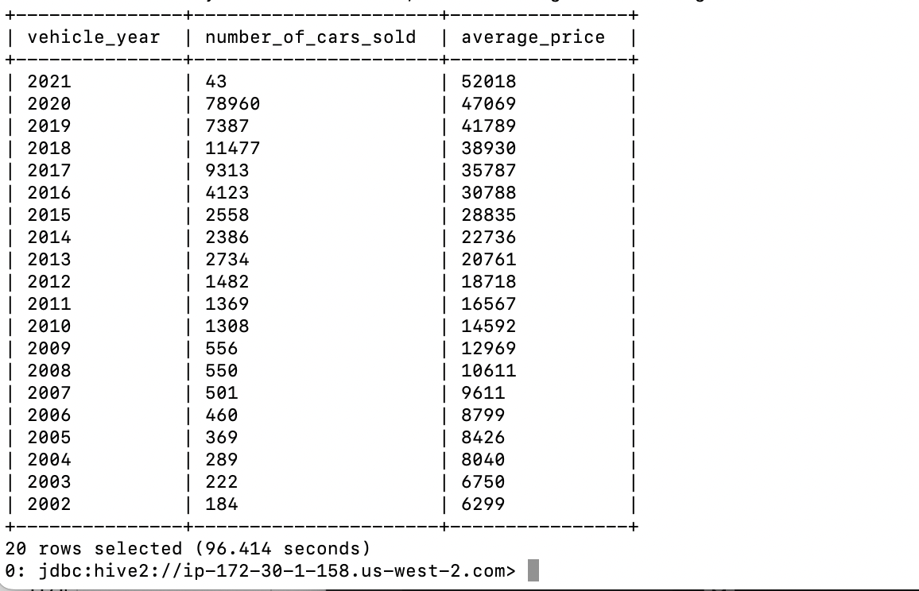

1. Next, you need to run the below command to dump the query result into HDFS file.

INSERT OVERWRITE DIRECTORY '/user/arupal/data/' ROW FORMAT DELIMITED FIELDS TERMINATED BY ',' select vehicle_year, count(vin) AS number_of_cars_sold, ceil(avg(price)) AS average_price from used_cars where CONCAT(make_name, " ", model_name) = 'Ford F-150' group by vehicle_year order by vehicle_year desc limit 20;

1. Downloading data into your PC- Open a Linux terminal to copy the data from HDFS to Linux directory. On the terminal, run an -ls command to verify that the file with query results was created.

$ hdfs dfs -ls data/

1. Next, copy the file from HDFS to Linux using the -get command

$ hdfs dfs -get data/000000_0 carpriceford.csv

1. Now, you can remove the file from HDFS using the following command

$ hdfs dfs -rm data/000000_0

1. Transfer the file “carpriceford.csv” to your personal computer using ‘scp’ and your account name.

$ scp arupal@129.146.154.176:/home/arupal/carpriceford.csv .

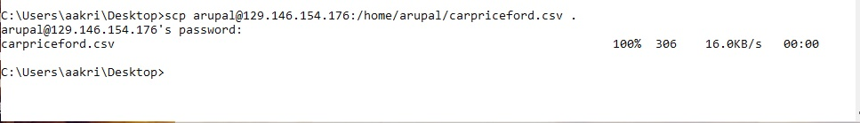

1. Visualization in Excel - You need to create a line graph for the visual representation of the output. Open excel and insert the first line with the column names, “vehicle_year”, “number_of_cars_sold” and “average_price”.
2. Distribution of used cars sales across different cities in the US
3. For the next analysis, you need to run the below command to find out the distribution of car sales across different cities in the US.

select city As city, count(vin) AS no_of_cars_sold from used_cars group by city order by count(vin) desc LIMIT 10;

1. Verify that the output is as below.

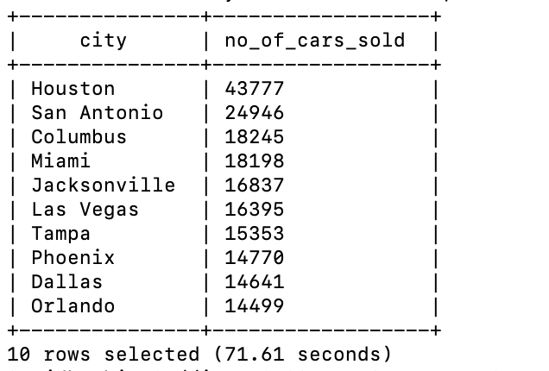

1. Next, you need to run the below command to move the query result to HDFS file.

INSERT OVERWRITE DIRECTORY '/user/arupal/data/' ROW FORMAT DELIMITED FIELDS TERMINATED BY ',' select city As city, count(vin) AS no_of_cars_sold from used_cars group by city order by count(vin) desc LIMIT 10;

1. Downloading data into your PC - Switch to the Linux terminal to copy the data from HDFS to Linux directory. Run an -ls command on Linux to verify that the file with query results was created

$ hdfs dfs -ls data/

1. Next, copy the file from HDFS to Linux using the -get command

$ hdfs dfs -get data/000000_0 carpricecity.csv

1. Now, you can remove the file from HDFS using the following command

$ hdfs dfs -rm data/000000_0

1. Transfer the file “carpricecity.csv” to your personal computer using ‘scp’ and your account name.

$ scp arupal@129.146.154.176:/home/arupal/carpricecity.csv .

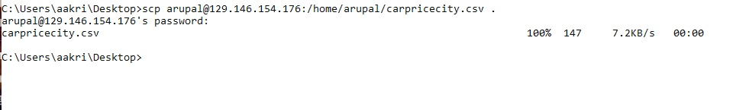

1. Visualization in Excel: You need to create a 3-D pie-chart for visual representation of the output. Open the file in excel and add headers into the first row; “city”, “number_of_cars_sold”. Next, insert a pie-chart, by selecting the data, click INSERT > Pick 3-D pie chart. Verify that the visualization is as per the below screenshot:
2. Effect of a car accident on price of the car
3. In this analysis, you need to run the below command to see how the car price gets affected if the car has an accident history.

select avg(used_car_temp.savings_amount/used_car_temp.price)*100 discount_percent, used_car_temp.has_accidents has_accident from (select * from used_cars where mileage < 10000) used_car_temp where CONCAT(used_car_temp.make_name, " ", used_car_temp.model_name) = 'Ford F-150' AND used_car_temp.has_accidents IS NOT NULL group by used_car_temp.has_accidents;

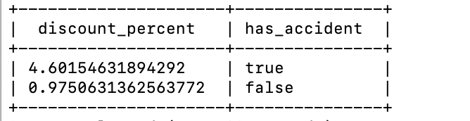

1. Effect of car accident on days on market
2. Moving on to the last descriptive analysis, you need to run this code to notice how is the days on market for a car is affected if it has an accident history.

select ceil(avg(daysonmarket)) AS average_days_on_market, has_accidents from used_cars WHERE has_accidents IS NOT NULL group by has_accidents ORDER BY avg(daysonmarket);

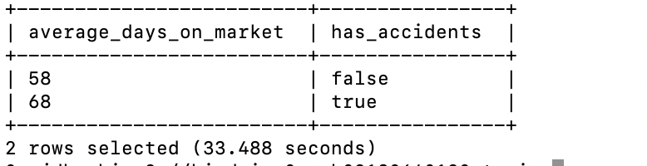

### Step 9: Factors Affecting Used Car Prices (Statistical approach) – From the descriptive analysis you found that there are certain parameters/attributes that are critical to used car prices. These are:

* Car Model
* Has accident (Does car have an accident history)
* Number of owners
* Days on market
* Vehicle year (year when the car was released)
* Mileage

For the next set of analysis, to determine the effect of above attributes on car price, you need to do the following:

* Run analysis for a selected variable keeping all the other variables constant – This is needed to ensure that other variables do not affect the price of the car. Only the effect of the selected variable on the price of car can be analyzed
* Bucket continuous variables – To keep some of the variables constant, you need to bucketize the continuous variables (daysonmarket, mileage and vehicle year). This will help simplify the analysis when running group by queries later in the tutorial.
* Create a new HDFS directory for the new used_cars_analysis table
* Export data from used_cars table to a new table used_cars_analysis to simplify the Hive QL queries

1. Create used_cars_analysis table – Run the below commands to create a used_cars_analysis table
2. You need to run the below command to create a new HDFS directory used_cars_analysis to export the data that will be used for statistical analysis

$ hdfs dfs -mkdir used_cars_analysis

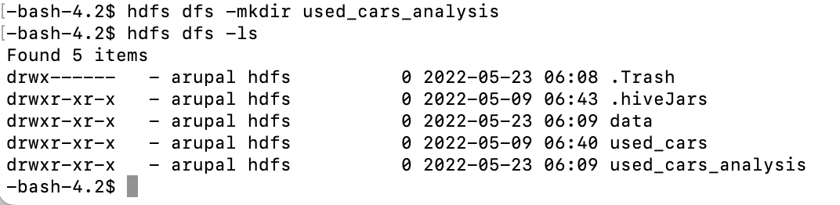

1. Below command runs a select query to bucketize the continuous variables and exports it to a file which you will use to create the used_cars_analysis table

INSERT OVERWRITE DIRECTORY '/user/arupal/used_cars_analysis/' ROW FORMAT DELIMITED FIELDS TERMINATED BY ',' SELECT avg(price),car_sales_analysis.car_model,car_sales_analysis.has_accident,car_sales_analysis.number_of_owners,car_sales_analysis.days_on_market,car_sales_analysis.vehicle_year,car_sales_analysis.mileage, count(*) FROM (SELECT price AS price, CONCAT(make_name," ",model_name) AS car_model,has_accidents AS has_accident,owner_count AS number_of_owners,IF(daysonmarket<=30,"0-30 days",IF((daysonmarket>30 AND daysonmarket<=90),"30-90 days",IF((daysonmarket>90 AND daysonmarket<=180),"90-180 days","More than 180 days"))) AS days_on_market,IF(vehicle_year>=2020,"0-2 years",IF((vehicle_year>=2017 AND vehicle_year<=2019),"3-5 years",IF((vehicle_year>=2011 AND vehicle_year<=2016),"5-10 years","More than 10 years"))) AS vehicle_year,IF(mileage<=10000,"Less than 10000 miles",IF((mileage>10000 AND mileage<=30000),"10000 to 30000 miles",IF((mileage>30000 AND mileage<=100000),"30000 to 100000 miles","More than 100000 miles"))) AS mileage FROM used_cars) car_sales_analysis GROUP BY car_sales_analysis.car_model,car_sales_analysis.has_accident,car_sales_analysis.number_of_owners,car_sales_analysis.days_on_market,car_sales_analysis.vehicle_year,car_sales_analysis.mileage;

1. Create the analysis table - You need to use the following command to create a used_cars_analysis table that will be used to query the price of the used car with respect to one factor.

CREATE EXTERNAL TABLE IF NOT EXISTS used_cars_analysis (price DECIMAL(12,2), car_model VARCHAR(64), has_accident BOOLEAN, number_of_owners INTEGER, days_on_market VARCHAR(64), vehicle_year STRING, mileage VARCHAR(64), number_of_rows INTEGER) ROW FORMAT DELIMITED FIELDS TERMINATED BY ',' STORED AS TEXTFILE LOCATION '/user/arupal/used_cars_analysis';

1. Run the below command to see if the table is created in your database.

show tables;



1. Then, use the SELECT command to see the data in the used_cars_analysis table.

select * from used_cars_analysis LIMIT 5;

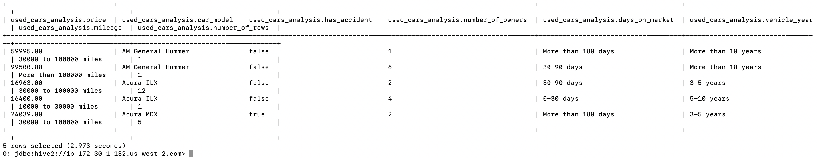

1. Analyze the factors affecting used car prices depending on number of owners
2. Now you need to run the following command to see the effect on the price of the car with number of owners, when car_model = Ford F-150, has_accidents = False, mileage < 1000 miles, days on market is 0-30 days and vehicle year is 5-10 years.

select ceil(avg(price)) AS average_car_price, number_of_owners AS no_of_owners from used_cars_analysis where car_model = "Ford F-150" AND has_accident = FALSE AND mileage = "Less than 10000 miles" AND days_on_market = "0-30 days" AND vehicle_year = "5-10 years" group by number_of_owners ORDER BY avg(price);

1. Verify that the output is as per below:

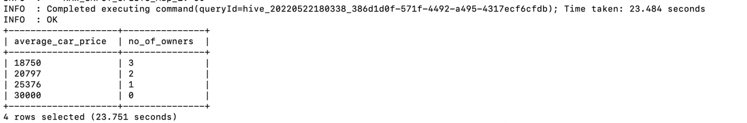

1. Run the below command to dump the query result into HDFS file.

INSERT OVERWRITE DIRECTORY '/user/arupal/data/' ROW FORMAT DELIMITED FIELDS TERMINATED BY ',' select ceil(avg(price)) AS average_car_price, number_of_owners AS no_of_owners from used_cars_analysis where car_model = "Ford F-150" AND has_accident = FALSE AND mileage = "Less than 10000 miles" AND days_on_market = "0-30 days" AND vehicle_year = "5-10 years" group by number_of_owners ORDER BY avg(price);

1. Downloading data to PC: On the linux terminal, run the below command to verify that the file with query results was created.

$ hdfs dfs -ls data/

1. Next, copy the file from HDFS to Linux using the -get command

$ hdfs dfs -get data/000000_0 carpriceowners.csv

1. Now, you can remove the file from HDFS using the following command

$ hdfs dfs -rm data/000000_0

1. Remotely download the output “carpriceowners.csv” to your PC using the below scp command

$ scp arupal@129.146.154.176:/home/arupal/carpriceowners.csv .

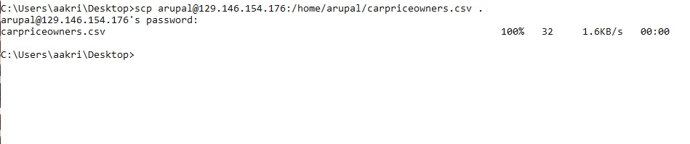

1. Visualization in Excel- Open excel and insert the first row to add headers to the data; “average_car_price” and “no_of_owners”. Now, select the data you want to include in the chart. Next, go to INSERT > choose a 3-D column chart. Verify that the output visualization looks like the below bar chart.
2. Analyze the factors affecting used car prices depending on number of vehicle year
3. For the second analysis, you need to determine the price of the car with respect to number of vehicle years when other factors have a constant value as given in the code below.

select ceil(avg(price)) AS average_car_price, vehicle_year from used_cars_analysis where car_model = "Ford F-150" AND has_accident = FALSE AND number_of_owners = 0 AND days_on_market = "0-30 days" AND mileage = "Less than 10000 miles" group by vehicle_year ORDER BY avg(price);

1. The output from the above command would look like the following:

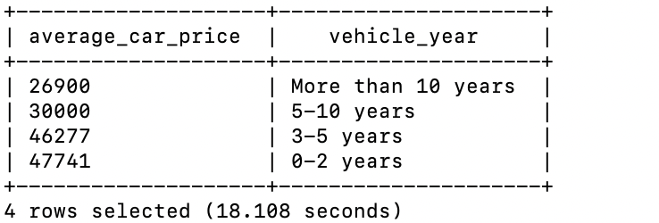

1. Run the below command to dump the query result into HDFS file.

INSERT OVERWRITE DIRECTORY '/user/arupal/data/' ROW FORMAT DELIMITED FIELDS TERMINATED BY ',' select ceil(avg(price)) AS average_car_price, vehicle_year from used_cars_analysis where car_model = "Ford F-150" AND has_accident = FALSE AND number_of_owners = 0 AND days_on_market = "0-30 days" AND mileage = "Less than 10000 miles" group by vehicle_year ORDER BY avg(price);

1. Downloading data to PC: Switch to the Linux terminal to copy the data from HDFS to Linux directory. On the Linux terminal, run an -ls command to verify that the file with query results was created.

$ hdfs dfs -ls data/

1. Next, copy the file from HDFS to Linux using the -get command

$ hdfs dfs -get data/000000_0 carpricevehicleyr.csv

1. Now, you can remove the file from HDFS using the following command

$ hdfs dfs -rm data/000000_0

1. Remotely download the output “carpricevehicleyr.csv” to your PC using the below scp command

$ scp arupal@129.146.154.176:/home/arupal/carpricevehicleyr.csv .

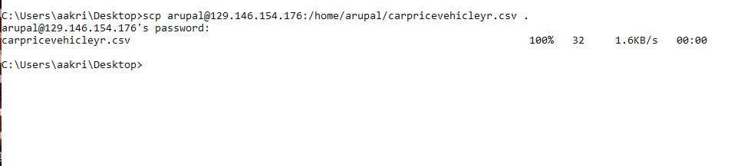

1. Visualization in Excel: Open excel and insert the first row to add headers to the data; “average_car_price” and “vehicle_year”. Now, select the data you want to include in the chart. Go to INSERT > choose a 3-D column chart.

### Step 10: Geo- Spatial Visualizations – Now, you will work on (3) geo spatial visualizations using excel 3D map and Power BI. These visualizations are useful for a quick and easy insight into patterns and trends from the analysis.

1. Distribution of used cars sales across different cities in the US
2. For the distribution of used car sales across different cities in the US, you need to use the output of the select command that you ran in Step 8e.

select city As city, count(vin) AS no_of_cars_sold from used_cars group by city order by count(vin) desc LIMIT 10;

1. Next, run the below command (without LIMIT) to export the data for all the US cities in the dataset to the “data” directory

INSERT OVERWRITE DIRECTORY '/user/arupal/data/' ROW FORMAT DELIMITED FIELDS TERMINATED BY ',' select city As city, count(vin) AS no_of_cars_sold from used_cars group by city order by count(vin) desc;

1. Downloading data to PC: Switch to the Linux terminal to copy the data from HDFS to Linux directory. On the Linux terminal, run an -ls command to verify that the file with query results was created.

$ hdfs dfs -ls data/

1. Next, copy the file from HDFS to Linux using the -get command

$ hdfs dfs -get data/000000_0 cardistributiongeo.csv

1. Now, you can remove the file from HDFS using the following command

$ hdfs dfs -rm data/000000_0

1. Remotely download the output “cardistributiongeo.csv” to your PC using the below scp command

$ scp arupal@129.146.154.176:/home/arupal/ cardistributiongeo.csv .

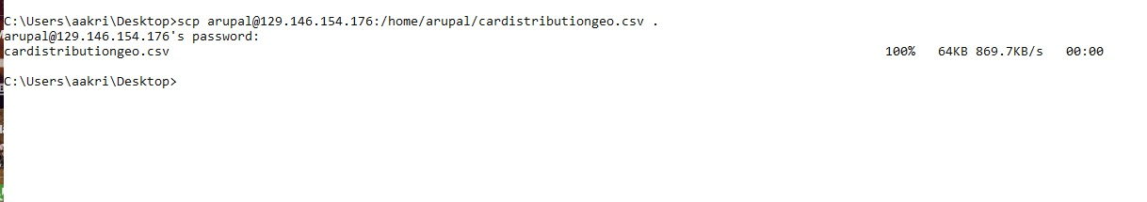

1. Visualization in excel 3D Maps: Open the file in an excel and insert a blank first row to add headers “city” and “no_of_cars_sold” to the file. Select the data for the visualization and click on INSERT> 3D Maps> Open 3D Maps.

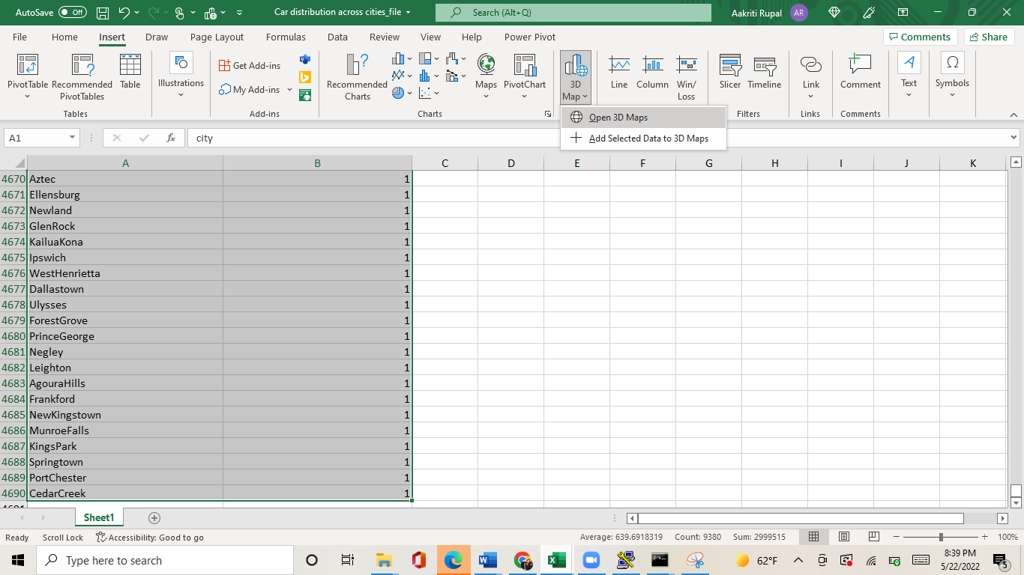

1. Change the visualization to clustered column. Set location to City, Height to no_of_cars_sold and Category to city. You would see height depicting the no_of_cars_sold is largest at Houston.

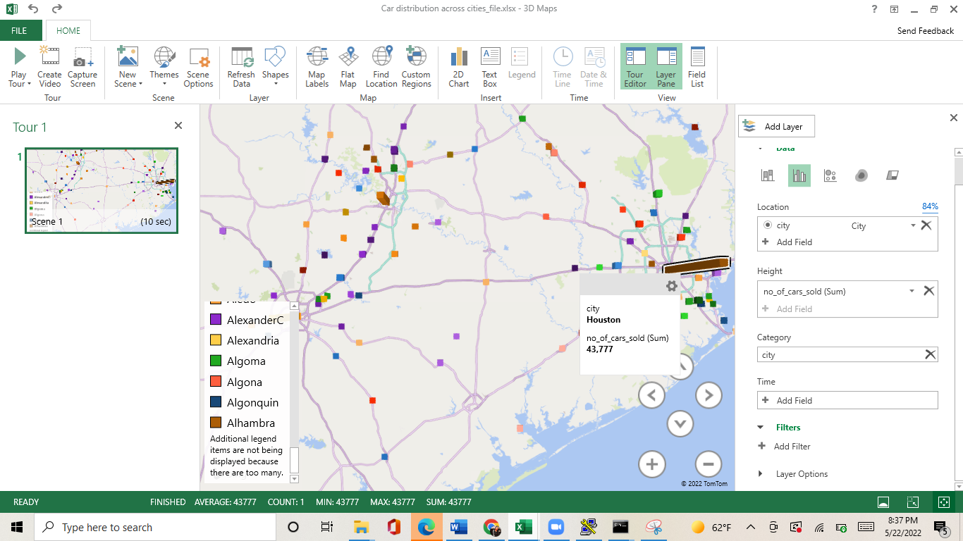

1. Used car price distribution across cities
2. Geospatial visualization that shows the price distribution of used cars across all cities.

SELECT used_car_plot.city AS city, avg(used_car_plot.latitude) AS avg_latitude, avg(used_car_plot.longitude) AS avg_longitude, used_car_plot.price_range AS price_range, count(*) AS num_of_cars FROM (SELECT IF(price<=20000,"Less than $20000",IF((price>20000 AND price<=40000),"$20000 to $40000",IF((price>40000 AND price<=100000),"$40000 to $100000", "More than $100000"))) AS price_range, city, latitude, longitude FROM used_cars) used_car_plot group by used_car_plot.city, used_car_plot.price_range LIMIT 10;

1. Verify that the output is as per below: 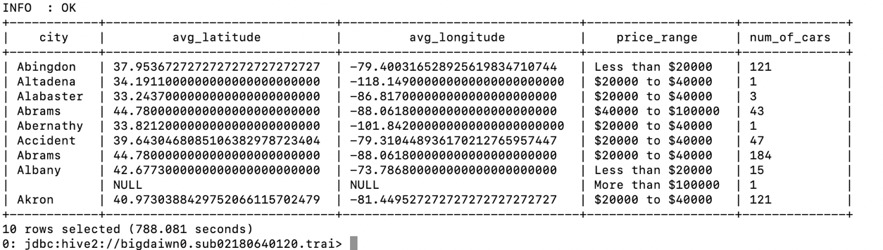
2. Run the below command without LIMIT to export the data for all the US used cars price distribution across cities in the dataset.

INSERT OVERWRITE DIRECTORY '/user/arupal/data/' ROW FORMAT DELIMITED FIELDS TERMINATED BY ',' SELECT used_car_plot.city AS city, avg(used_car_plot.latitude) AS avg_latitude, avg(used_car_plot.longitude) AS avg_longitude, used_car_plot.price_range AS price_range, count(*) AS num_of_cars FROM (SELECT IF(price<=20000,"Less than $20000",IF((price>20000 AND price<=40000),"$20000 to $40000",IF((price>40000 AND price<=100000),"$40000 to $100000", "More than $100000"))) AS price_range, city, latitude, longitude FROM used_cars) used_car_plot group by used_car_plot.city, used_car_plot.price_range;

1. Downloading data to PC: Switch to the Linux terminal to copy the data from HDFS to Linux directory. On the linux terminal, run an -ls command to verify that the file with query results was created.

$ hdfs dfs -ls data/

1. Next, copy the file from HDFS to Linux using the -get command

$ hdfs dfs -get data

1. Now, you can remove the file from HDFS using the following command

$ hdfs dfs -rm data

1. Remotely download the output in data directory to your PC using the below scp command

$ scp -r [arupal@129.146.154.176:/home/arupal/data](mailto:arupal@129.146.154.176:/home/arupal/data) .

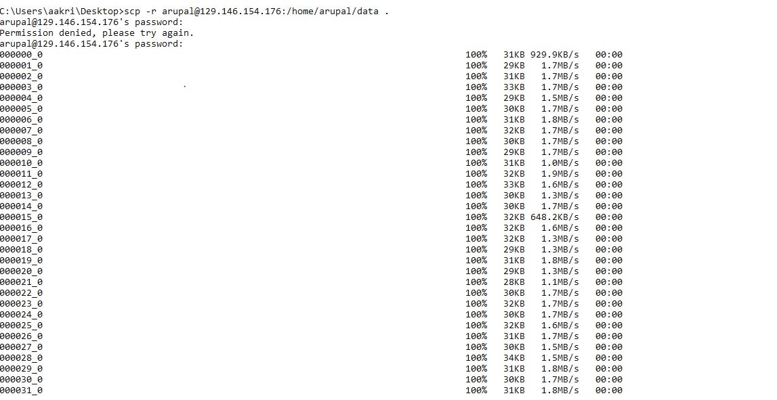

1. Run a merge command to merge all the files created in the “data” directory. You need to run the below command in the directory where all the downloaded data was saved. Last argument in the command is the output file (merged) that will be created

copy * merged_file.csv

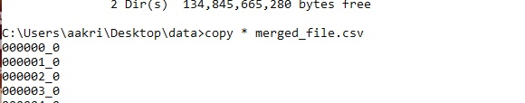

1. You will see the below window showing that the merge is complete

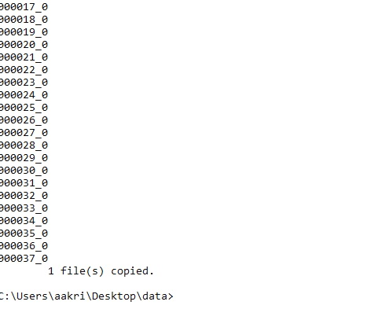

1. Visualizing data in Power BI: Open the file in excel, insert a first new row, and add the following headers, city, latitude, longitude, car_price, number_of_cars.
2. Sign into Power BI website using your school account to import the output into Power BI.
3. Open a web browser and sign in with your school account at (<https://powerbi.microsoft.com/en-us/>)

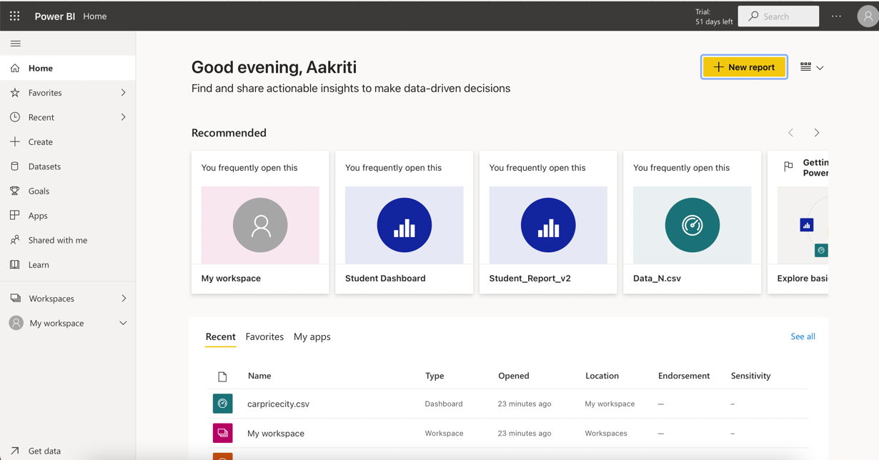

1. After you sign in, go to my workspace > Click on New > Upload a file

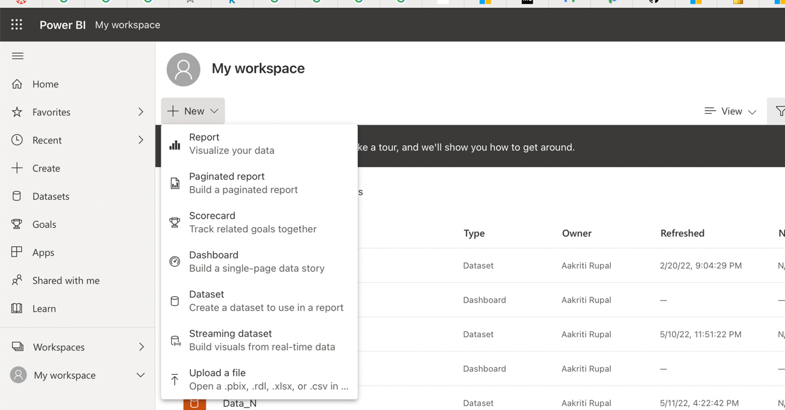

1. Next, click on Upload a file > Local file > Select your .csv file from local computer or laptop.

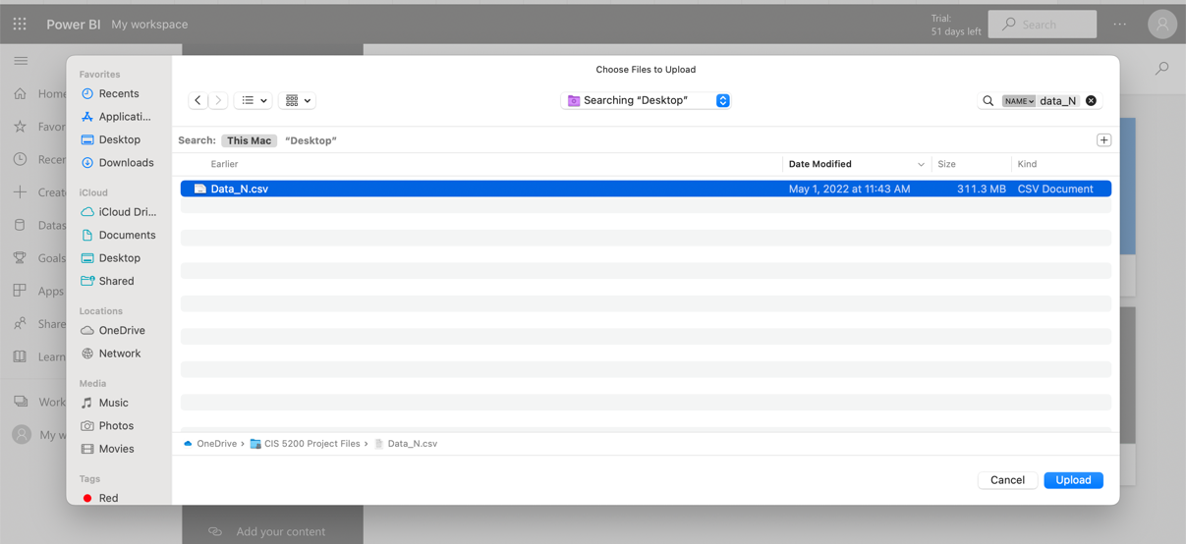

1. On clicking upload, the file gets uploaded to Power BI and then a window pop of “Go to Dashboard” appears. Click on *Go to Dashboard* as highlighted in red in the below screenshot.

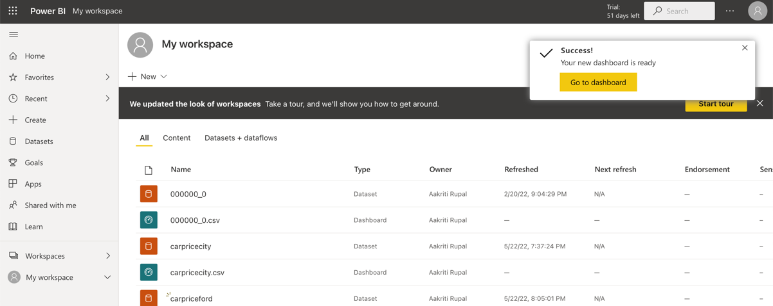

1. Then click on the .csv file uploaded. This will open a new screen that shows the different visualizations to be used on the right side of the screen. Select map visualization from the visualization list.

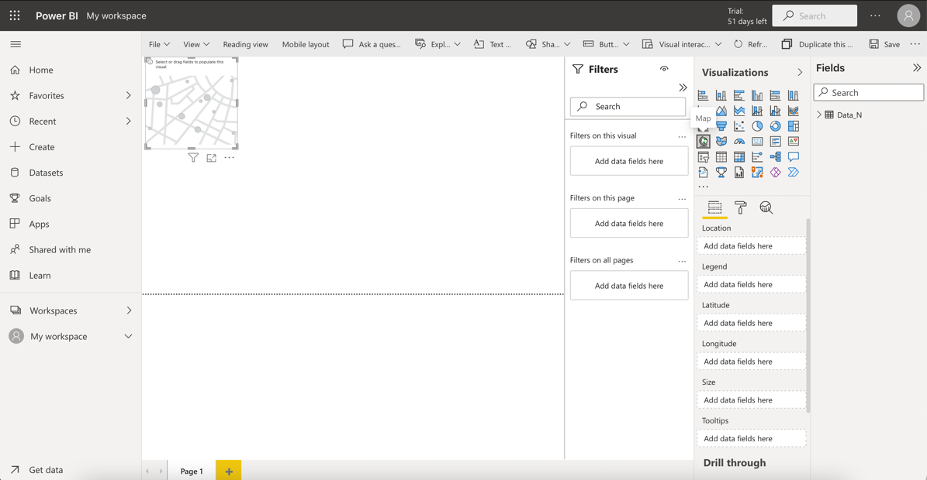

1. Next, click on the file and expand it to fit the screen. Now you need to select Location as city, Legend as car_price and Size as sum_of_number_of_cars. Verify your output from the screenshot below.

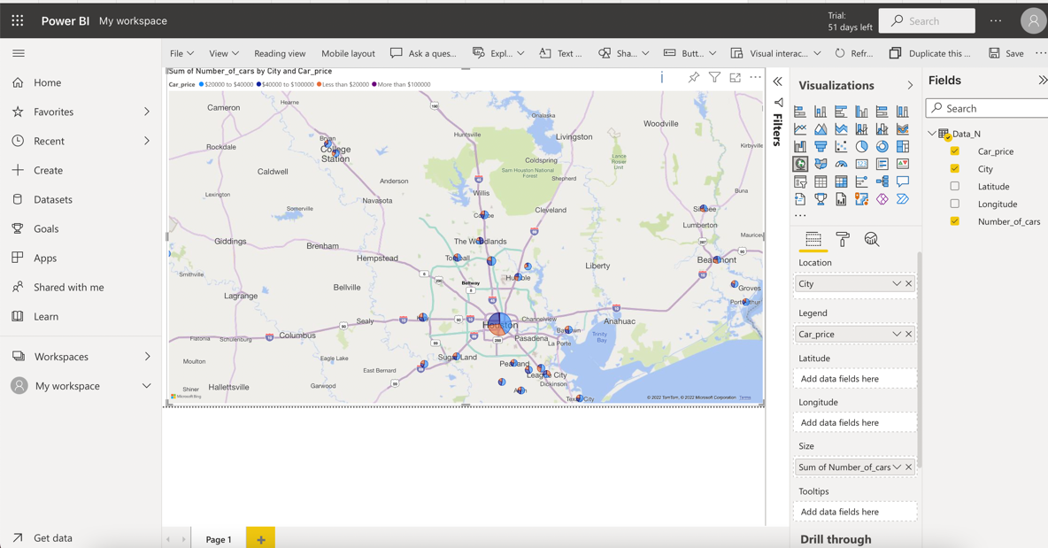

1. Geo Spatial Visualization for used cars across the US west coast
2. Visualization using Power BI: You use the same file as in Step 10b above for the geo spatial visualization showing the distribution of car sales across the US west coast cities. Once the map visualization is complete (Previous step), click on the dataset on the left side of the dashboard, select the .csv file to be used for the visualization from the list of uploaded datasets.

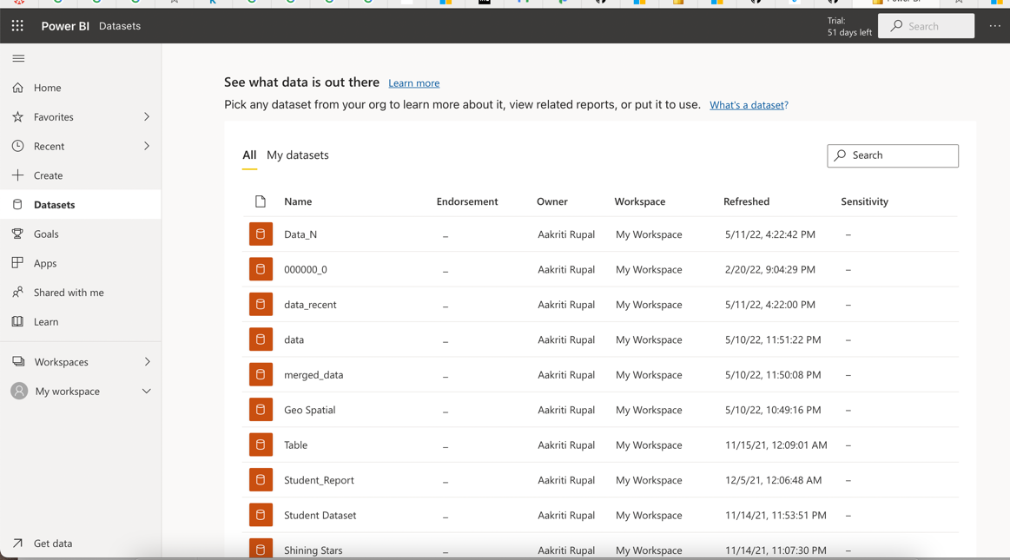

1. Click on create a report under “vertical option dots” button (as shown in the screenshot). This will bring you to the visualization dashboard.

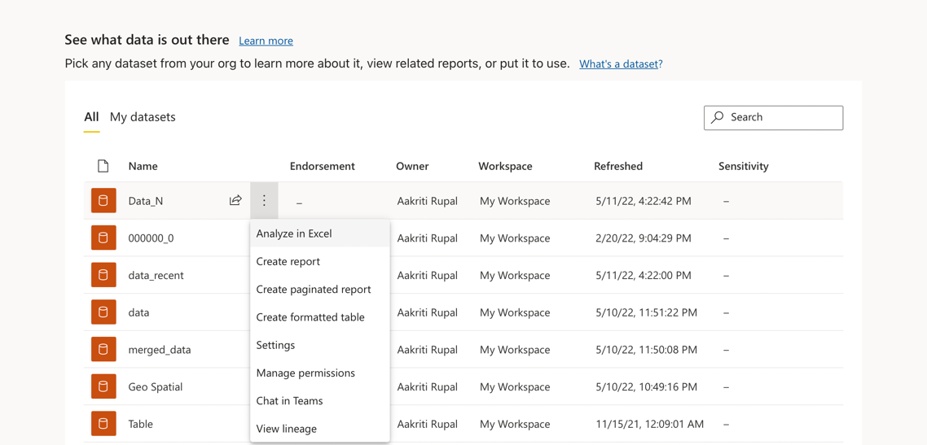

1. On the visualization dashboard, select filled maps from the list of visualizations.

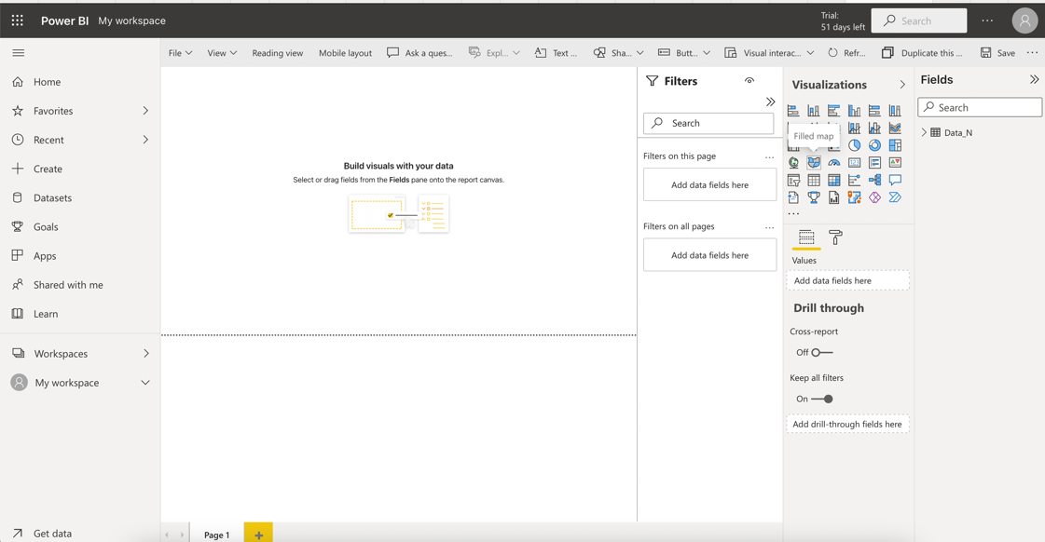

1. Select the location as city and drag the .csv file to fit the pane. You will see areas dark patches in the areas where the car sales distribution is the highest.

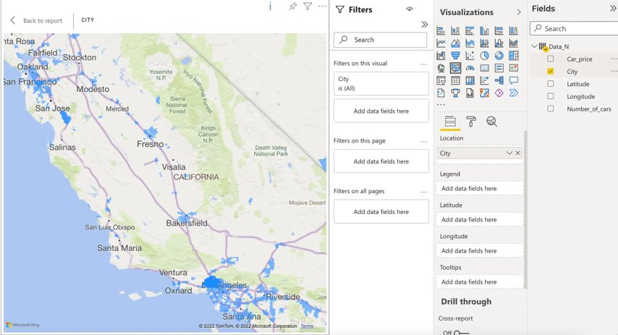

## Summary

In this tutorial you learnt how to use Hive and HDFS to run analysis on large datasets. You also learnt to import the results of Hive into Microsoft Excel and Power BI for visualization.

## References

* 1. URL of Data Source – <https://www.kaggle.com/ananaymital/us-used-cars-dataset>
  2. URL of your GitHub - <https://github.com/arupal23/CIS-5200-Project-Files>
  3. URL of Power BI - <https://app.powerbi.com/>